International
Workshop on Electrochemistry
of Electroactive Materials
WEEM-2019

Borovets, Bulgaria
June 16th - June 21st, 2019

FIRST CIRCULAR

Organizing Committee

Chairpersons
V. Tsakova (Bulgria), M. A. Vorotyntsev (Russia/France)

Scientific Committee
D. Aurbach (Israel), V. Z. Barsukov (Ukraine), J. Heinze (Germany), A. R. Hillman (UK), G. Inzelt (Hungary), P. J. Kulesza (Poland), D. Mandler (Israel), V. M. Mirsky (Germany), O. A. Petrii (Russia), P. G. Pickup (Canada), R. Seeber (Italy), O. A. Semenikhin (Russia/Canada), M. Skompska (Poland), V. Tsakova (Bulgria), C. Visy (Hungary), M. A. Vorotyntsev (Russia/France)

Advisory Board
P. Mussini, A. Pailleret

Local Organizing Committee
V. Tsakova (chairperson), M. Ilieva, V. Karabozhikova. V. Lyutov, A. Nakova
Institute of Physical Chemistry, Bulgarian Academy of Sciences

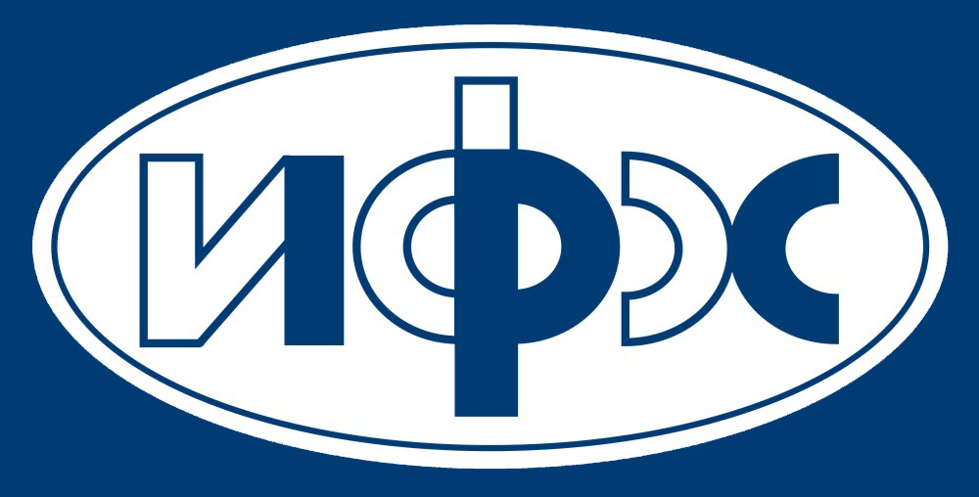  Institute of Physical Chemistry | 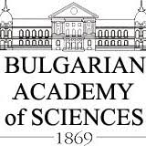

GENERAL INFORMATION

The International Workshop on Electrochemistry of Electroactive Materials (WEEM) is a scientific conference of a special type designed for the detailed analysis of the state-of-art and intensive discussions of key issues related to the research and applications of various chemical electroactive systems, such as electron-conducting and redox polymers, mixed-valence transition-metal inorganic solids, solid ion conductors revealing a sufficient electronic conductivity, in particular certain "superionic conductors" and lithium-cation conducting systems as well as composite organic-inorganic systems. A complete understanding of the complex mechanisms of their functioning in the course of the charging/discharging process, redox reactions of solute species at their surfaces, charge transfer at the interfaces between different components of these materials or their interaction with an external electromagnetic field, requires bringing together the leading researchers actively working in these fields to provide them with an opportunity to combine their presentations of original results with extensive exchange of opinions, with an emphasis on non-conventional approaches. This informal meeting will provide the venue for an in-depth analysis of unresolved challenges that will result in maximal stimulation of the further development of the area as well as creation of joint international teams for the future.
The WEEM meetings already organized in Russia (Moscow, 1995), France (Dourdan, 1997), Poland (Poraj, 2000), Germany (Bad Herrenalb, 2003), Russia (Repino, 2006), Poland (Szczyrk, 2009), Hungary (Szeged-Hódmezővásárhely, 2012) and Germany (Bad Herrenalb, 2015), fulfilled the above expectations. Significant progress in this area during the last years makes it actual to organize the next workshop of this series, this time in Borovets, Bulgaria.

On behalf of the Organizing Committee we invite you for participation in WEEM-2019.

Scope of the Conference

Contributions related to all aspects of electroactive materials and their composites, from their synthesis and characterization to potential or actual applications are welcome.

The scope includes (but is not limited to) the topics:

- Synthesis and characterization of electroactive (conducting/conjugated and redox) polymers and inorganic electroactive solids. Mechanisms of electrochemical and chemical synthetic routes to electroactive polymers.
- Electroactive copolymers, hybrid materials and nanocomposites containing metal, carbon, semiconductor or insulator particles/structures.
- Reactions at electrodes modified by electroactive materials or their (nano)composites.
- Recent developments of experimental techniques for characterization of pure and composite electroactive materials, with emphasis on in situ methods realized under control of the oxidation state of the system by the electrode potential.
- Applications of electroactive polymers, inorganic and composite materials: catalysis and electrocatalysis, electroanalysis, sensors and actuators, membranes, energy storage, batteries and supercapacitors, solar energy conversion, electrochromic and nonlinear-optic materials, nanosciences and molecular electronics etc, in relation to fundamental properties of the used electroactive material.

Participation of young researchers and scientists from interdisciplinary areas is strongly encouraged.
The workshop will include keynote, oral and poster presentations. Discussions of "hot topics" in the area will take place during the sessions. The official language is English.

Location

The conference will be held in Borovets (www.borovets-bg.com/en), a resort on the northern slopes of Bulgaria’s Rila Mountains, the gateway to Rila National Park. A detailed description of the transportation, accommodation at the conference place, social program for the participants as well as tourist attractions of the area will be given in the 2nd circular.
Our intent is to ensure accommodation for all participants in a single hotel which serves also as conference venue and thus to facilitate intensive and fruitful discussions of presentations, in combination with enjoying the beautiful mountain landscape of Rila.

Registration fees and accommodation

Similar to all preceding WEEPF/WEEM conferences, there will be a united conference fee which will cover all expenses for the workshop preparation, lodging and meals during the conference, coffee breaks, welcome party, banquet, and excursion on June 19th afternoon. The fee is anticipated to be in the range of 500 – 530 Euro for participants accommodated in a single room and to be reduced by 50 to 70 Euro for those sharing a double room. The exact values of the conference fee and methods of payment will be specified in the 2nd circular.
To facilitate the planning of the necessary accommodation capacities please make the pre-registration (see below) as early as possible.

Preliminary Schedule

- Arrival: Sunday afternoon (June 16th). Welcome party: Sunday evening
- Sessions: Monday, Tuesday, Wednesday morning, Thursday, Friday morning
- Excursion: Wednesday afternoon. Banquet (included in the conference fee): Wednesday evening
- Departure: Friday afternoon after lunch (June 21st)

Submission of Contributions (Pre-registration)
Those wishing to make a presentation at the workshop are kindly requested to submit resumes which will be considered by the Scientific Committee to attribute a form of presentation: keynote, oral or poster.
Please send an email message with attached file (doc or pdf, prepared with the use of the template attached here) with the resume (recommended volume of the resume itself: about 1 page), supplemented with requested additional information, to two addresses:

weem2019@ipc.bas.bg , mivo2010@yandex.com

Extended Abstracts (up to 3 pages) for the Conference Proceedings should be submitted at a later stage (until May 15, 2019) to allow their authors to provide the latest and/or more extended information.

Addresses for correspondence

Vessela Tsakova, Institute of Physical Chemistry, Bulgarian Academy of Sciences,
“Acad. G. Bonchev” str. Bl.11, BG-1113 Sofia, Bulgaria
tel.: +359 2 8719307, e-mail: weem2019@ipc.bas.bg, tsakova@ipc.bas.bg

Mikhail Vorotyntsev, e-mail: mivo2010@yandex.com, Skype: vorotyntsev

Website: http://www.ipc.bas.bg/ (available soon)

Important Dates

1 December2018 Deadline for preliminary registration and submission of short resume on the subject of the planned presentation
1 February 2019 Notification of acceptance of contributions and of the form of their presentations
1 February 2019 Distribution of the 2nd circular and of the application form for accommodation at the conference place
1 March 2019 Deadline for payment of the conference fee and for submission of the filled-in form for accommodation
15 May 2019 Deadline for submission of abstracts for the conference proceedings
05 June 2019 Distribution of the 3rd circular and the preliminary program
16 June 2019 Arrival to the conference place

